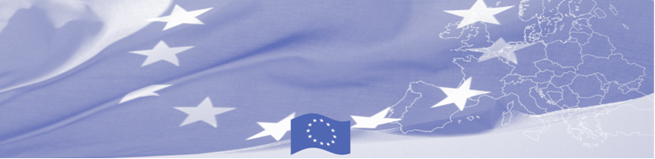
PRESS RELEASE

Capacity Building Workshop: Applied methodology for monitoring places of deprivation of liberty

On November 03-06, 2014 a capacity building workshop will take place in Osh on issues of applied methodology for detention monitoring. The preparation, implementation of and follow-up to monitoring visits will be discussed as well as the drafting of reports and the formulation of effective recommendations. The workshop will include a shadow monitoring session. This is the second part of a series of trainings for the staff of the NPM and of NGOs involved in monitoring the situation in closed institutions.
The workshop is organised within the project of “Strengthening the fight against torture and impunity in Kyrgyzstan: Prevention, Accountability, Remedy and Reparation”, which is funded by the European Union. The project aims at supporting legal and institutional reforms based on internationally recognized best practices and supporting the Kyrgyz National Preventive Mechanism (the National Centre for the Prevention of Torture) in its capacity building. The Ludwig Boltzmann Institute of Human Rights (BIM) and the Tian Shan Policy Center (TSPC) of the American University of Central Asia are implementing partners of the project.
For more information, please contact Andrea Schuechner, andrea.schuechner@univie.ac.at or Daniele Rumolo, rumolo_d@mail.auca.kg. Please visit the website of the Ludwig Boltzmann Institute of Human Rights at: http://bim.lbg.ac.at/en and the website of TSPC at: https://www.auca.kg/en/tspc/.

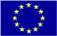  A project implemented by:  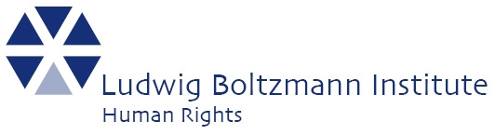  In partnership with | This project is funded by the European Union  Delegation of the European Union to the Kyrgyz Republic  21 Erkindik Boulevard, Business Centre Orionб 5th floor  Bishkek, 720040, Kyrgyz Republic  Telephone: +996 312 26 10 00  Fax: +996 312 26 10 07  E-mail: delegation-kyrgyzstan@eeas.europa.eu  Website:http://eeas.europa.eu/delegations/kyrgyzstan  Facebook: http://www.facebook.com/eudelkg | The European Union is made up of 28 Member States who have decided to gradually link together their know-how, resources and destinies. Together, during a period of enlargement of 60 years, they have built a zone of stability, democracy and sustainable development whilst maintaining cultural diversity, tolerance and individual freedoms. The European Union is committed to sharing its achievements and its values with countries and peoples beyond its borders.

